Chapter 3 Question 15 - Michael Streyle

##   
## Call:  
## lm(formula = concentration ~ time)  
##   
## Residuals:  
## Min 1Q Median 3Q Max   
## -0.5333 -0.4043 -0.1373 0.4157 0.8487   
##   
## Coefficients:  
## Estimate Std. Error t value Pr(>|t|)   
## (Intercept) 2.5753 0.2487 10.354 1.20e-07 ***  
## time -0.3240 0.0433 -7.483 4.61e-06 ***  
## ---  
## Signif. codes: 0 '***' 0.001 '**' 0.01 '*' 0.05 '.' 0.1 ' ' 1  
##   
## Residual standard error: 0.4743 on 13 degrees of freedom  
## Multiple R-squared: 0.8116, Adjusted R-squared: 0.7971   
## F-statistic: 55.99 on 1 and 13 DF, p-value: 4.611e-06

## (Intercept) time   
## 2.575333 -0.324000

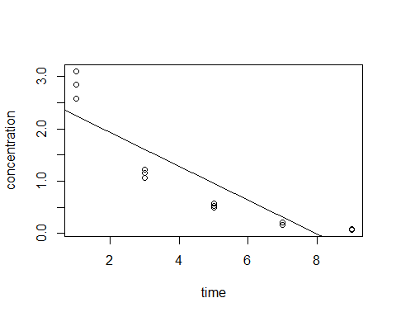

## Analysis of Variance Table  
##   
## Model 1: concentration ~ time  
## Model 2: concentration ~ 0 + as.factor(time)  
## Res.Df RSS Df Sum of Sq F Pr(>F)   
## 1 13 2.9247   
## 2 10 0.1574 3 2.7673 58.603 1.194e-06 ***  
## ---  
## Signif. codes: 0 '***' 0.001 '**' 0.01 '*' 0.05 '.' 0.1 ' ' 1

## [1] 38.50633